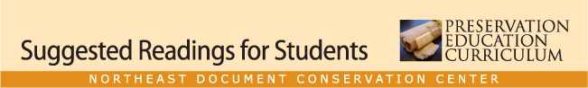

class 13 lesson plan

Building a Preservation Program

Banks, Paul N., and Roberta Pilette, eds. Preservation: Issues and Planning. Chicago: American Library Association, 2000.
Specifically: “Defining the Library Preservation Program: Policies and Organization,” by Carolyn Clark Morrow (pp. 1–27); “Planning for Preservation in Libraries,” by Jutta Reed-Scott (pp. 82–96); “Preservation Program Planning for Archives and Historical Records Repositories,” by Christine Ward (pp. 43–62); “Preservation Programs in High-Use Library Collections,” by Sara R. Williams (pp. 28–42); and “Programs, Priorities, and Funding,” by Margaret Child with Laura Word (pp. 63–81).
This is the key text for this lesson and the overall course. Reed-Scott and Ward are well-known authors and speakers in the field, and Child and Word both speak from the perspective of working for a funding organization and securing funds for preservation projects.
Northeast Document Conservation Center. Preservation of Library and Archival Materials. Andover, Mass.: Northeast Document Conservation Center, 2008. Particularly Section 1, Leaflets 1, 2, and 5; Section 7, Leaflet 7. http://www.nedcc.org/resources/leaflets.list.php
These leaflets can be used as assigned readings or in-class handouts. The highlighted publications deal with preservation planning, assessment, and collection policies and preservation; the last focuses on working with conservators, which many preservation managers do as part of staff management or outsourcing activities.
Smith, Abby. The Future of the Past: Preservation in American Research Libraries. Washington, D.C.: Council on Library and Information Resources, April 1999. Also available as Pub82 at http://www.clir.org/pubs/reports/reports.html
A brief but excellent paper on the past, present, and future of preservation planning and programs in the academic library environment.
SOLINET. http://www.solinet.net/Preservation.aspx. Particularly “Funding Resources for Preservation” and “Preservation Budget Planning.”

