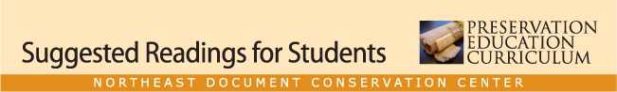

class 8 lesson plan

Treatment Options

Merrill-Oldham, Jan, and Nancy Carlson Schrock. “The Conservation of General Collections.” In Preservation: Issues and Planning, edited by Paul N. Banks and Roberta Pilette. Chicago: American Library Association, 2000.
National Information Standards Organization and the Library Binding Institute. Library Binding Standard, ANSI/NISO/LBI Z39.78-2000. Bethesda, Md.: NISO Press, 2000. http://download.www.techstreet.com/cgi-bin/pdf/free/234511/Z39-78.pdf
Paris, Jan. “Choosing and Working with a Conservator.” In Preservation of Library and Archival Materials. Andover, Mass.: Northeast Document Conservation Center, 2008. http://www.nedcc.org/resources/leaflets/7Conservation_Procedures/07ChoosingAConservator.php
Stewart, Eleanore. “Special Collections Conservation.” In Preservation: Issues and Planning, edited by Paul N. Banks and Roberta Pilette. Chicago: American Library Association, 2000.

